Building a Hybrid Web App on AWS (EC2 + CloudFront + S3)
For this project, my goal was to design and deploy a simple hybrid web architecture in which an EC2 instance serves HTML, while S3 and CloudFront deliver static assets securely and efficiently. This hands-on build reinforced core AWS architectural principles in networking, security, and performance optimization.

Project Goal
I set out to host a lightweight web application using three key AWS services:
- EC2 → Serves the main HTML page
- S3 → Stores static content (CSS + images)
- CloudFront → Distributes the static assets globally with low latency
This architecture allowed me to separate dynamic content from static content, reduce computing workload on EC2, and enforce more secure access patterns.

Architecture Overview
Here’s how the components interacted:
- Users access the public web page hosted on EC2
- The HTML references the CloudFront domain
- CloudFront retrieves the assets from S3
- S3 remains private — assets aren’t publicly accessible except through CloudFront
By forcing access through CloudFront, I improved performance and security posture.

What I Built Step-by-Step
Creating the S3 Bucket
I created a private S3 bucket to hold style.css and a logo image. I intentionally kept public access blocked to verify that CloudFront would be the only service able to retrieve these objects.
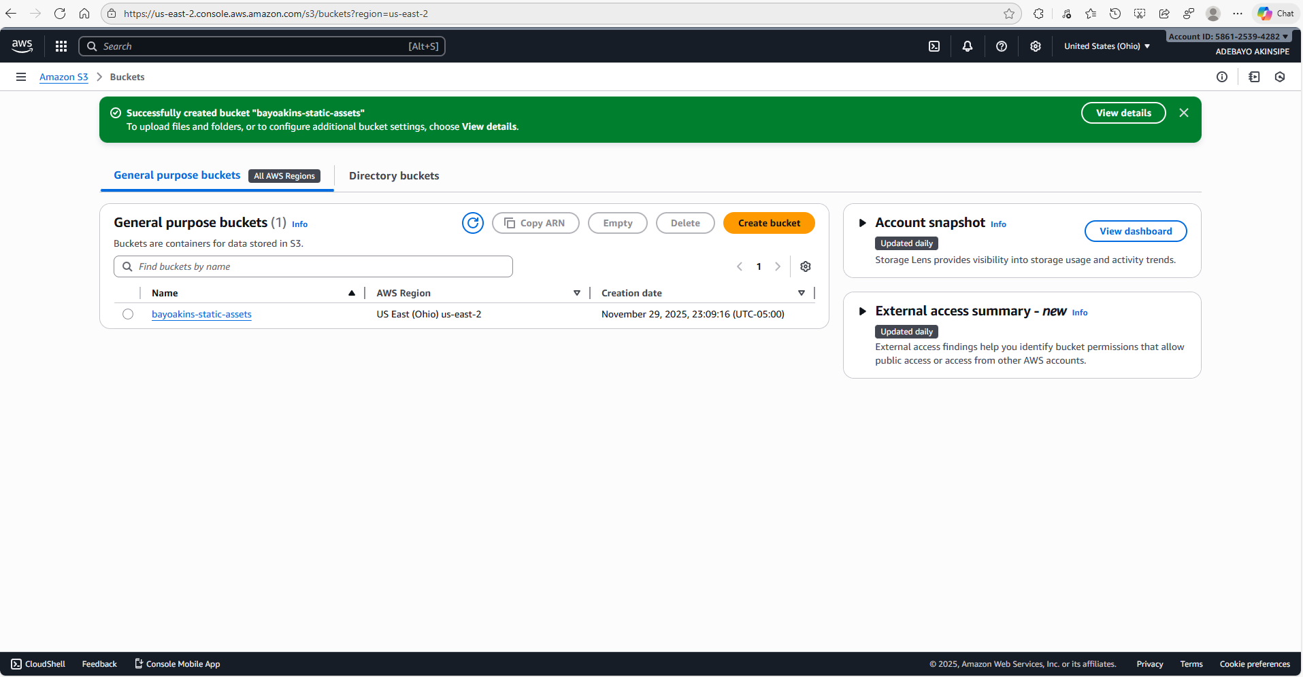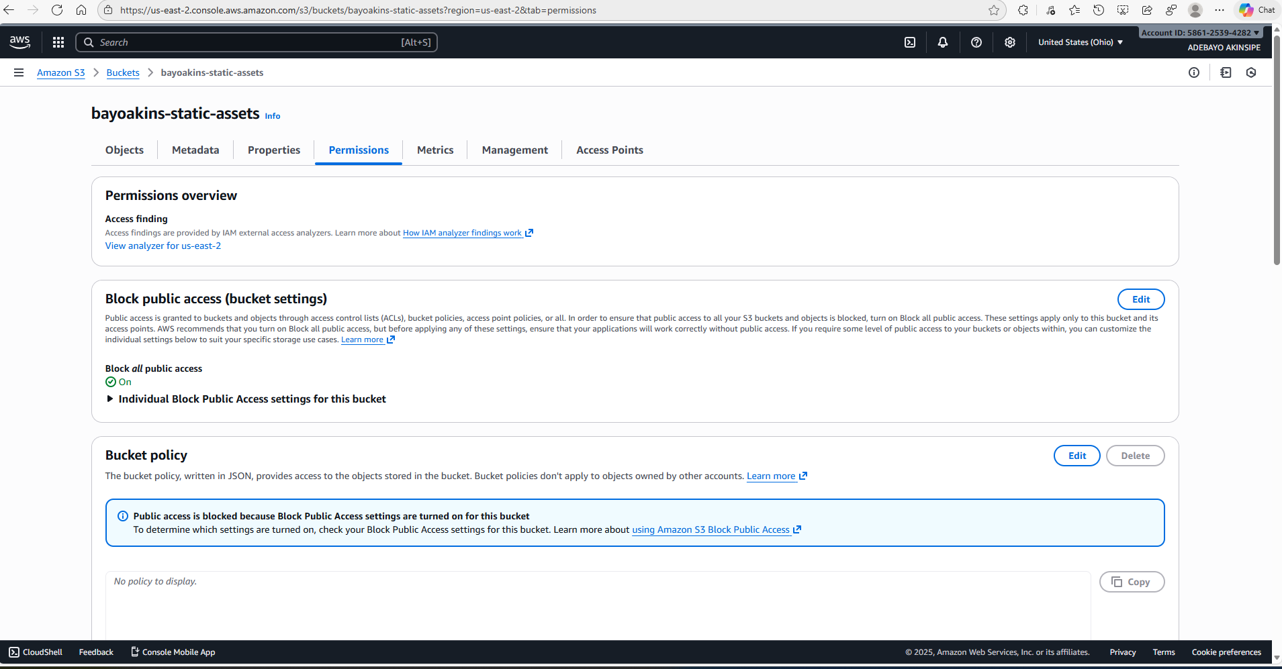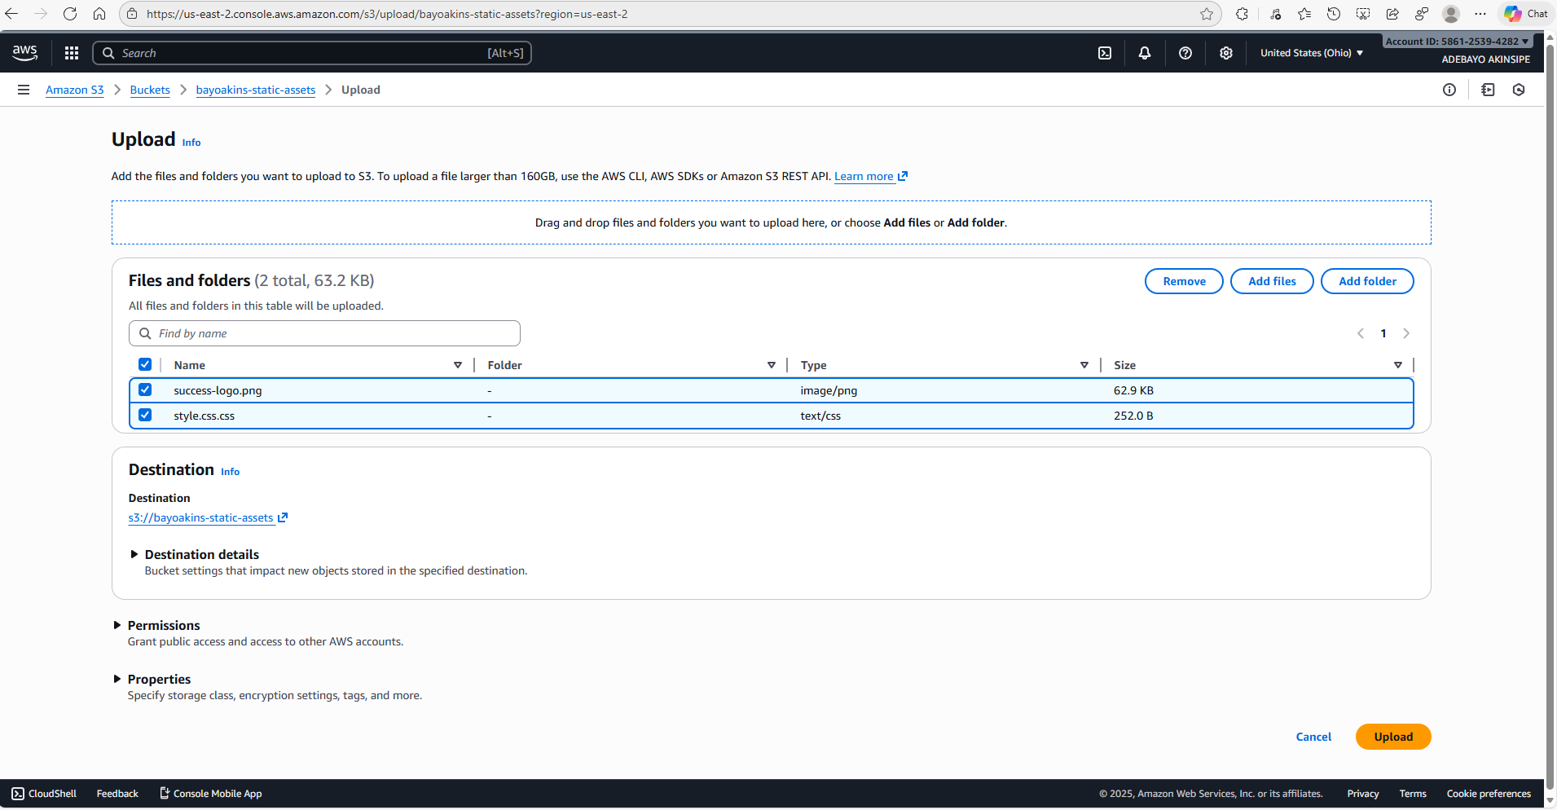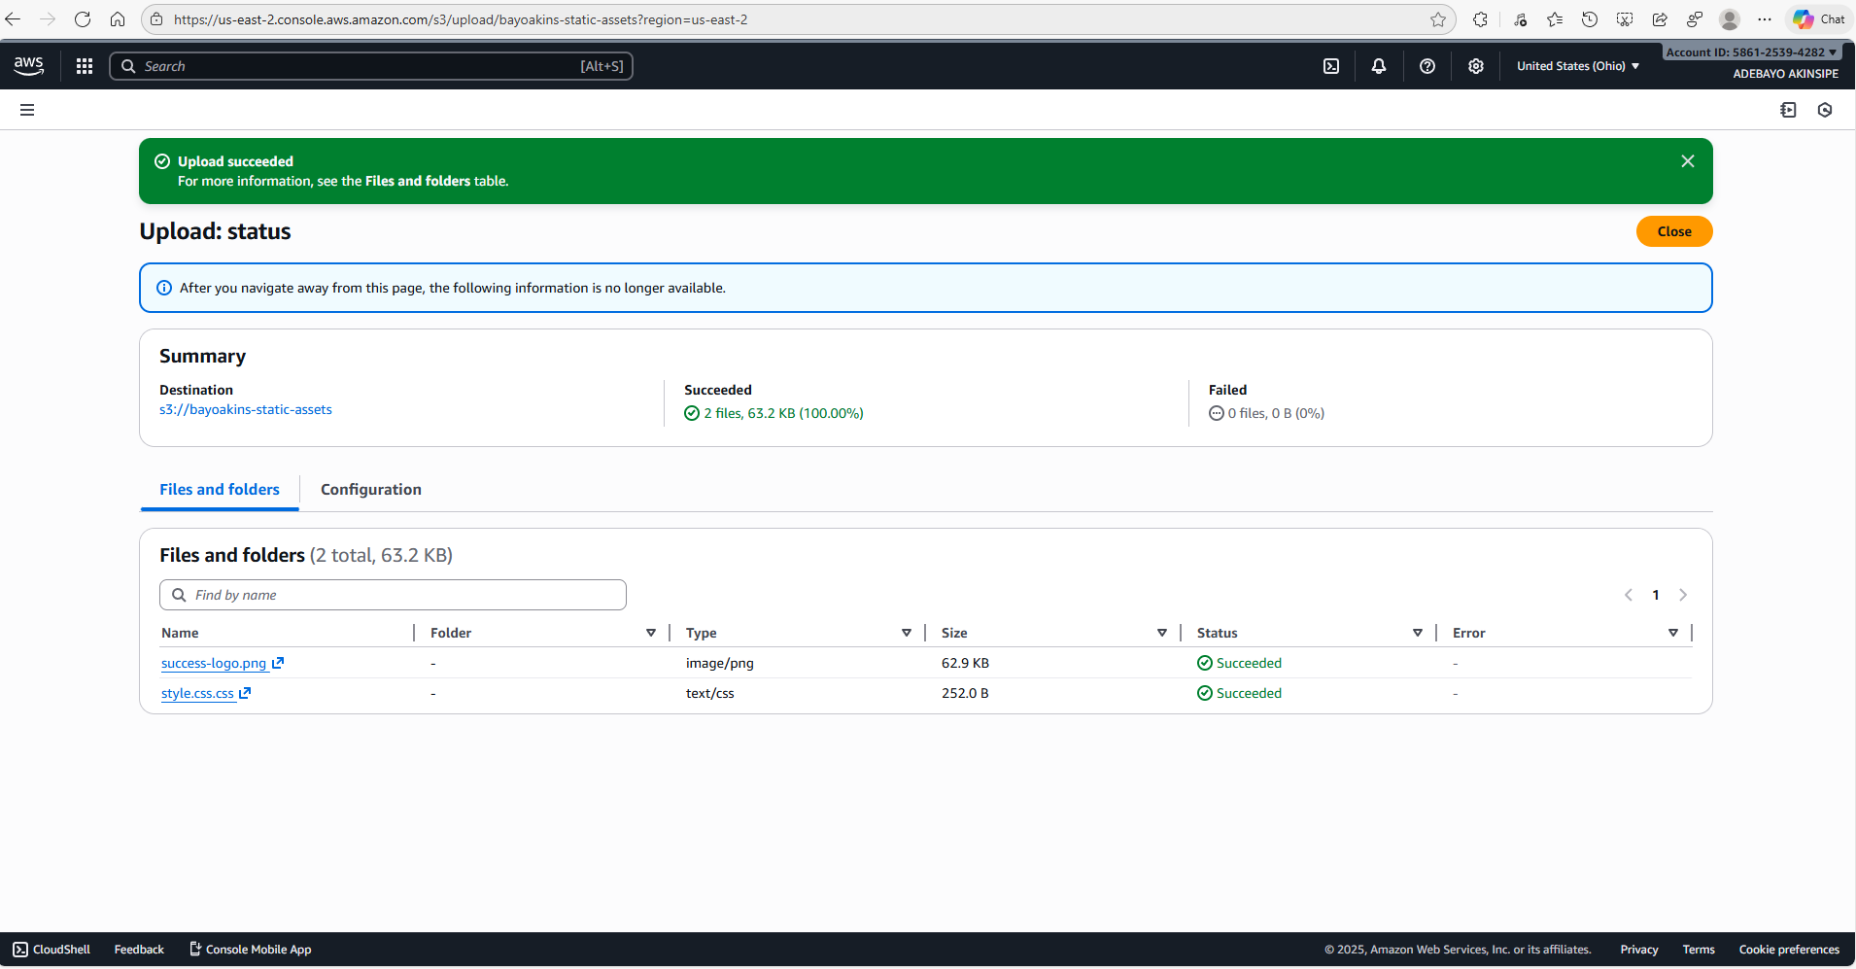
Setting Up CloudFront
Next, I configured a CloudFront Distribution that pointed to the S3 bucket. Once active, I copied the CloudFront domain name — this became the reference inside my HTML and CSS calls.
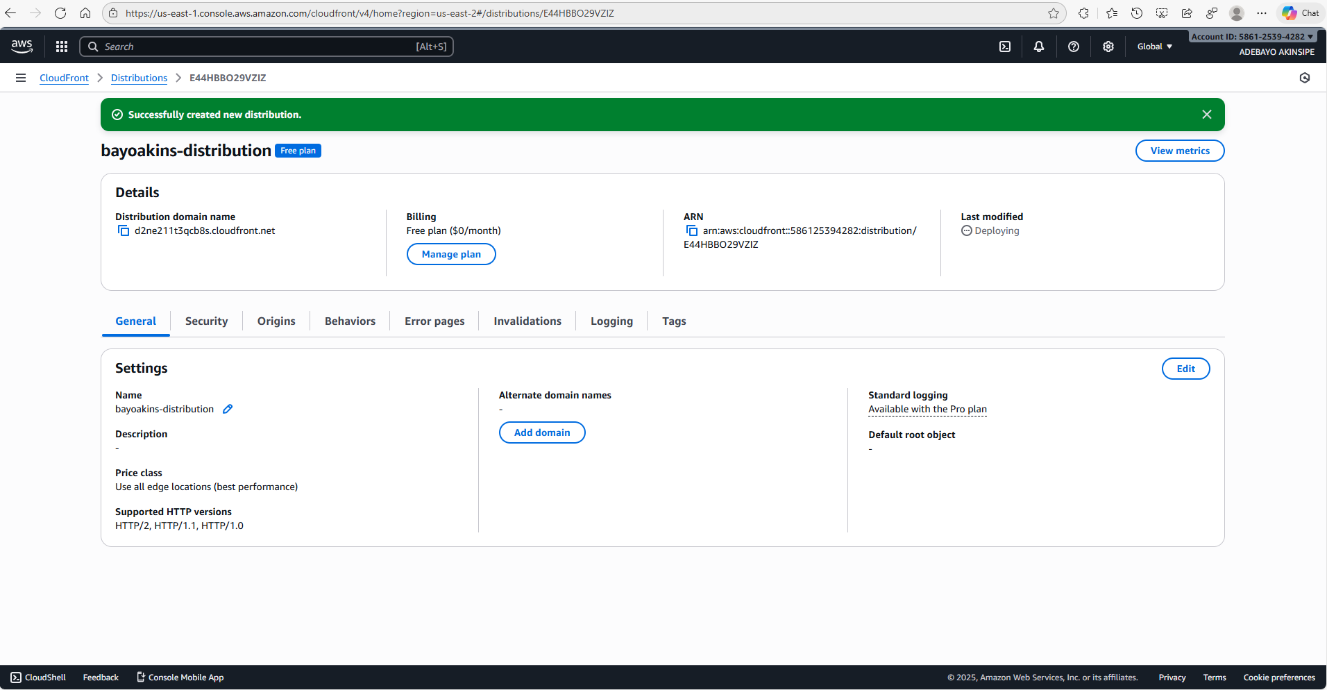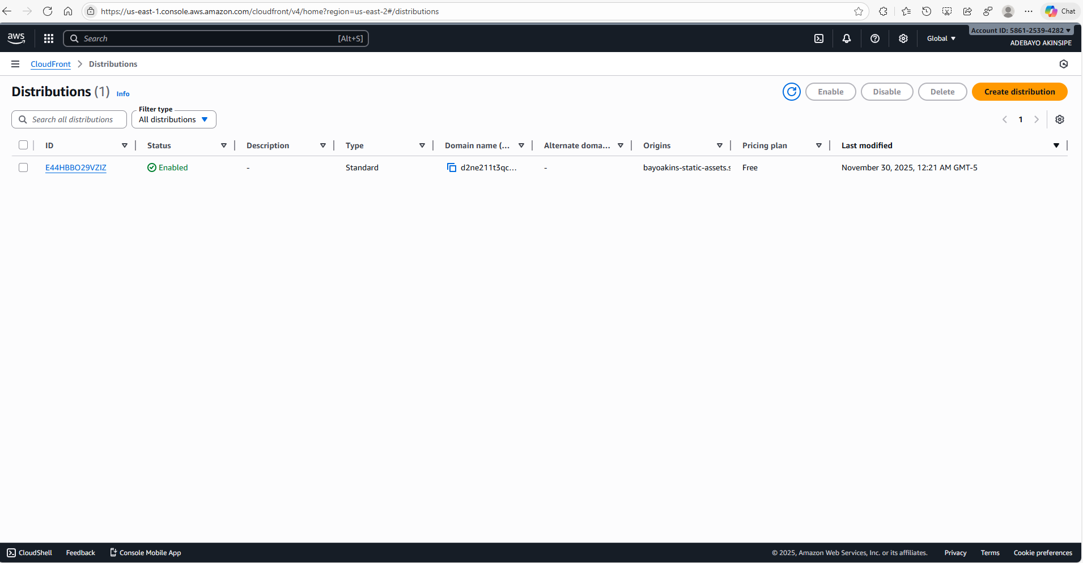
Launching the EC2 Instance, SSH into EC2, and Installing Apache
I deployed an Amazon Linux 2023 EC2 instance using a t2.micro instance type and enabled inbound HTTP traffic while restricting SSH access to my IP address. After connecting to the instance via PuTTY, I installed Apache and prepared it to serve the HTML file.
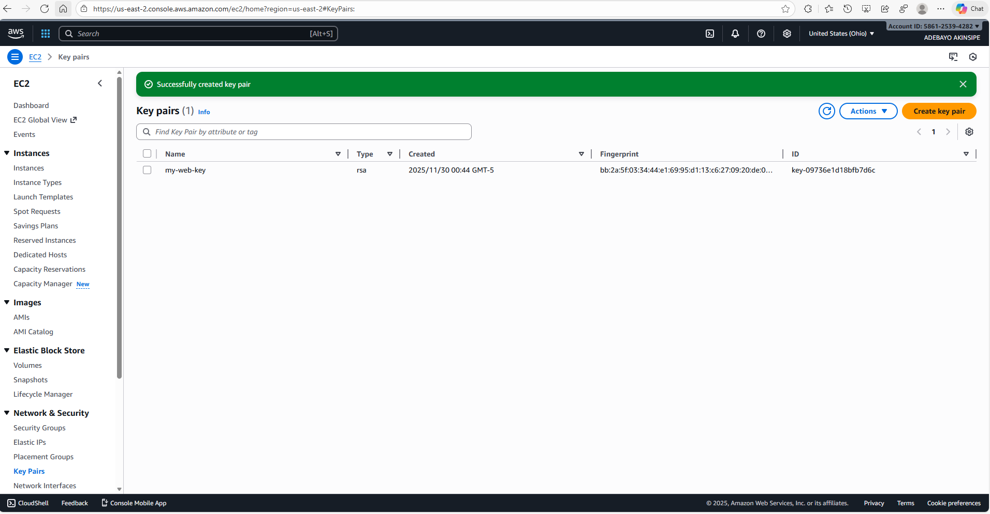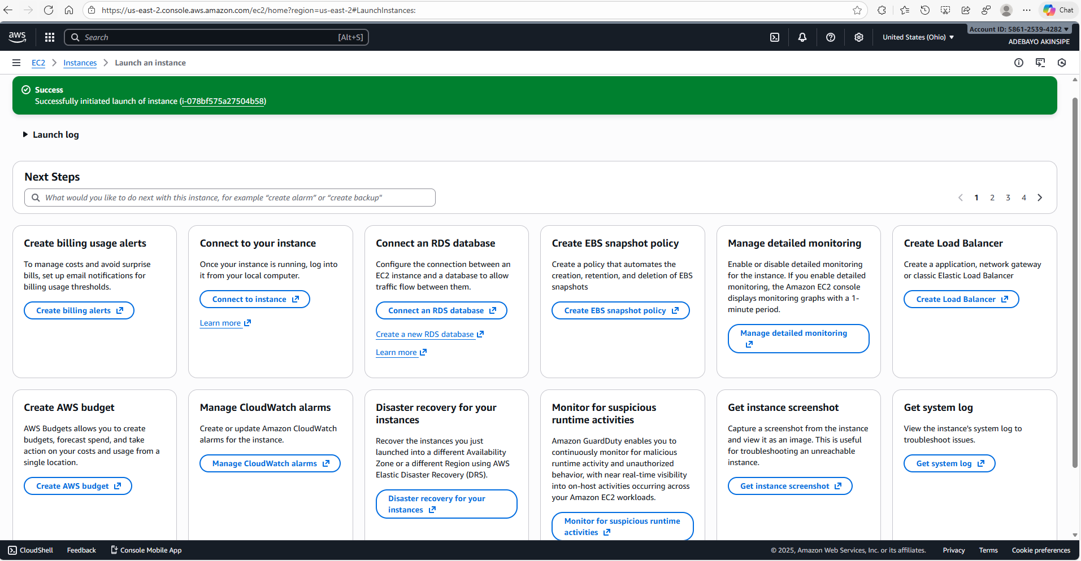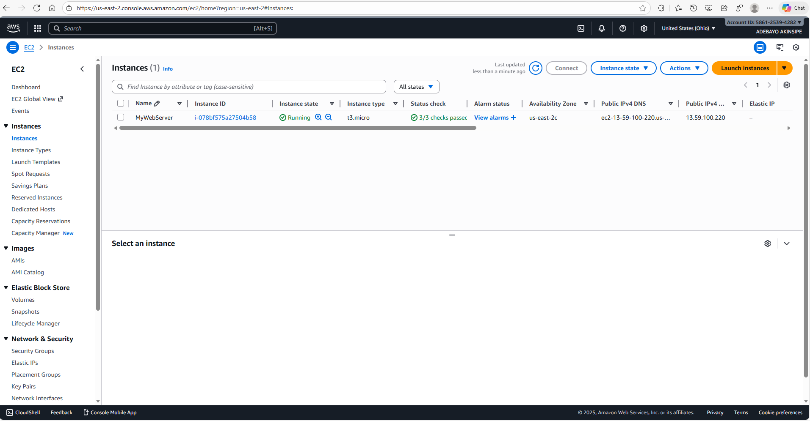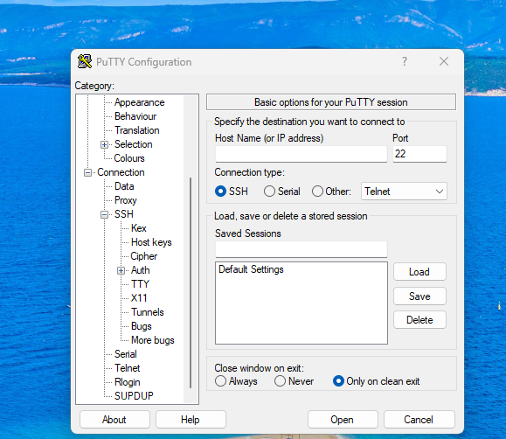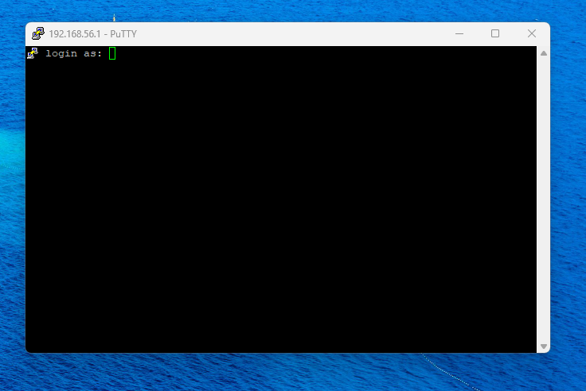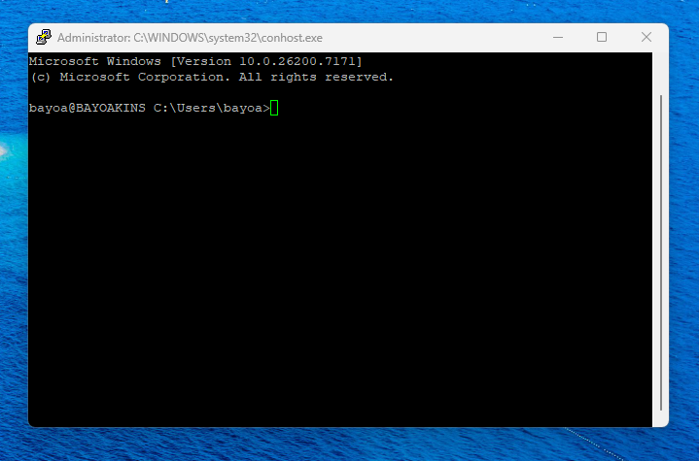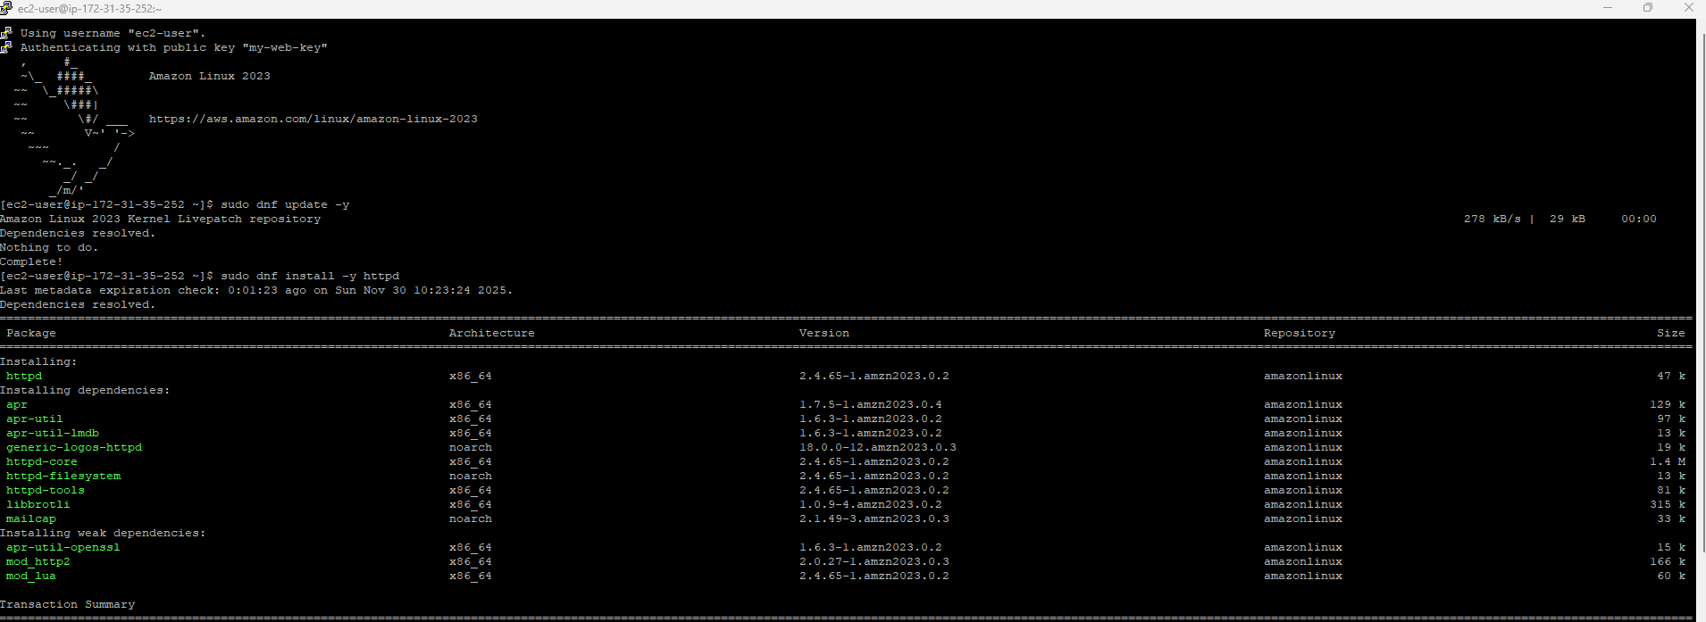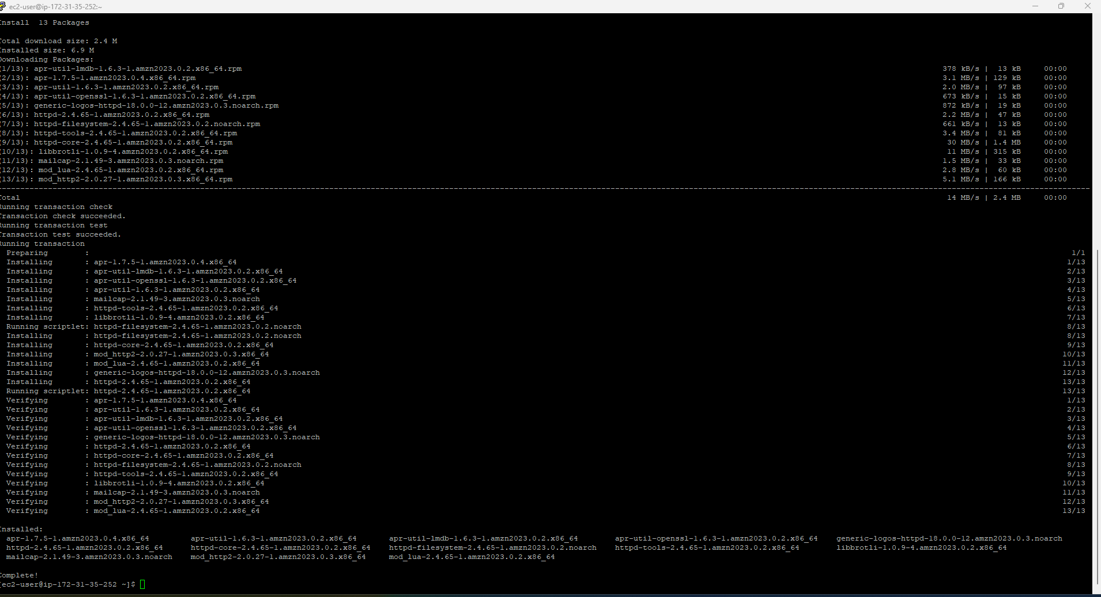
Linking Everything in HTML
Inside /var/www/html/index.html, I created a basic web page that referenced the CloudFront-hosted CSS and the success image.
Once saved, loading the EC2 public IP displayed the final, formatted output — a blue background, a message, and the centered logo — confirming that both content paths were working.
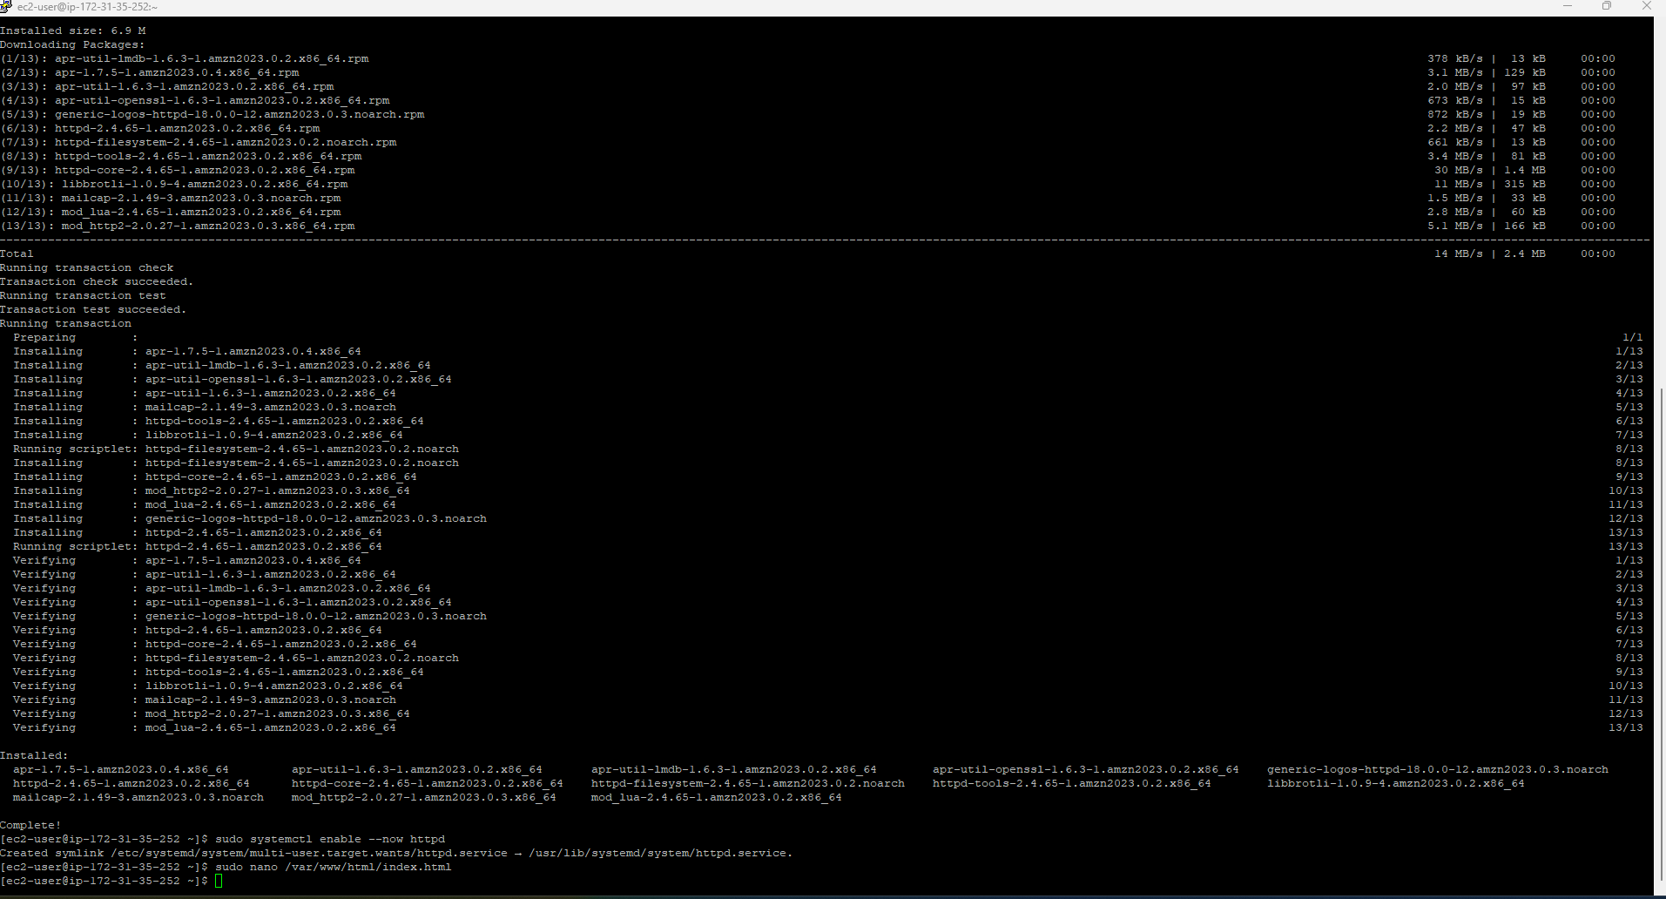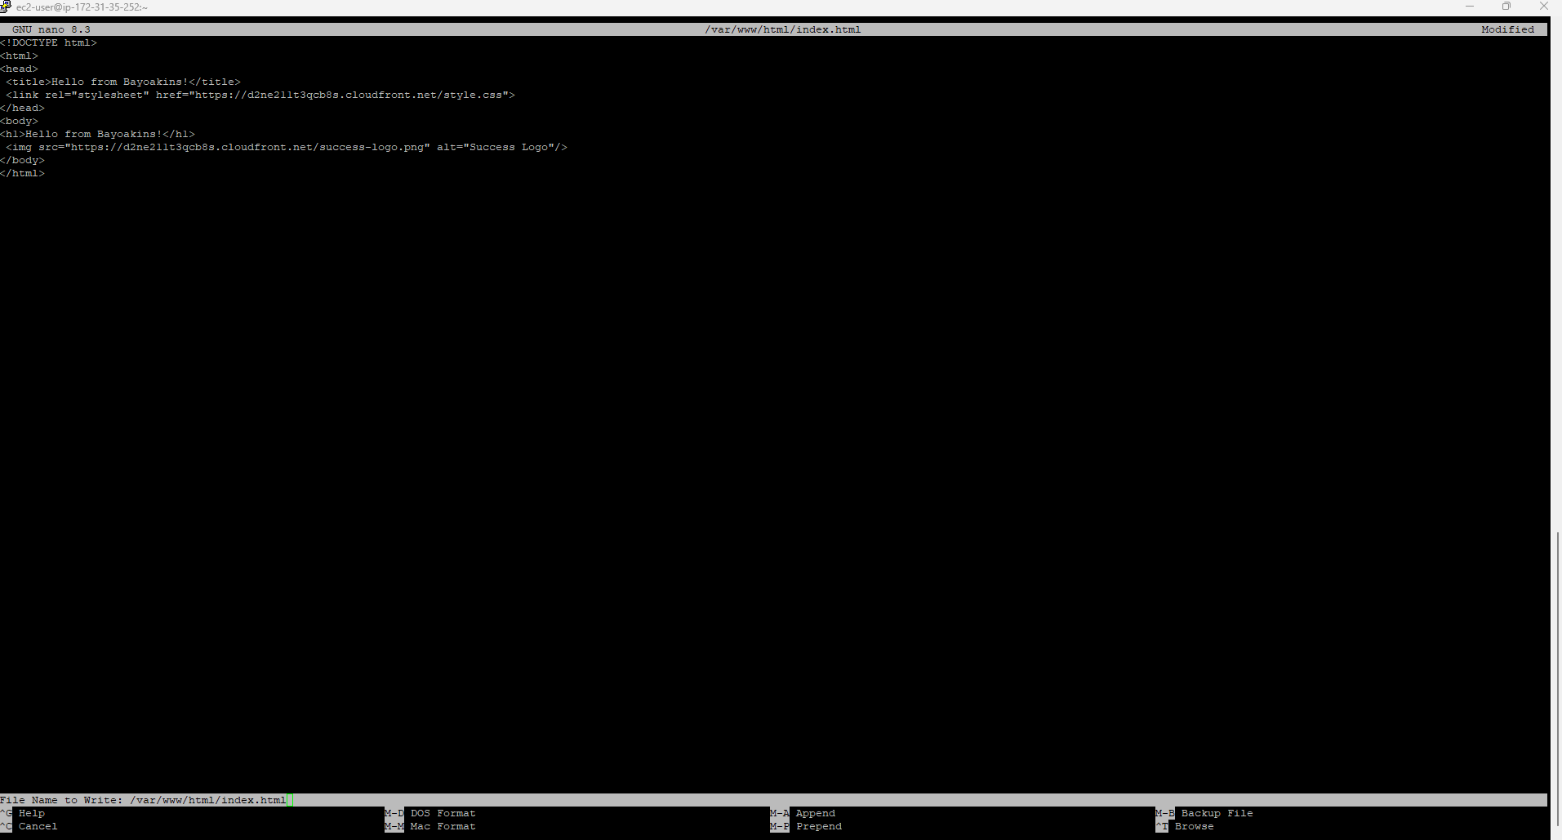

Testing Results
Once deployment was complete, I verified that:
- EC2 successfully served HTML
- S3 remained private (no direct access allowed)
- CSS and image loaded only through CloudFront
- The browser displayed all elements correctly
This validated that the hybrid architecture behaved as expected.
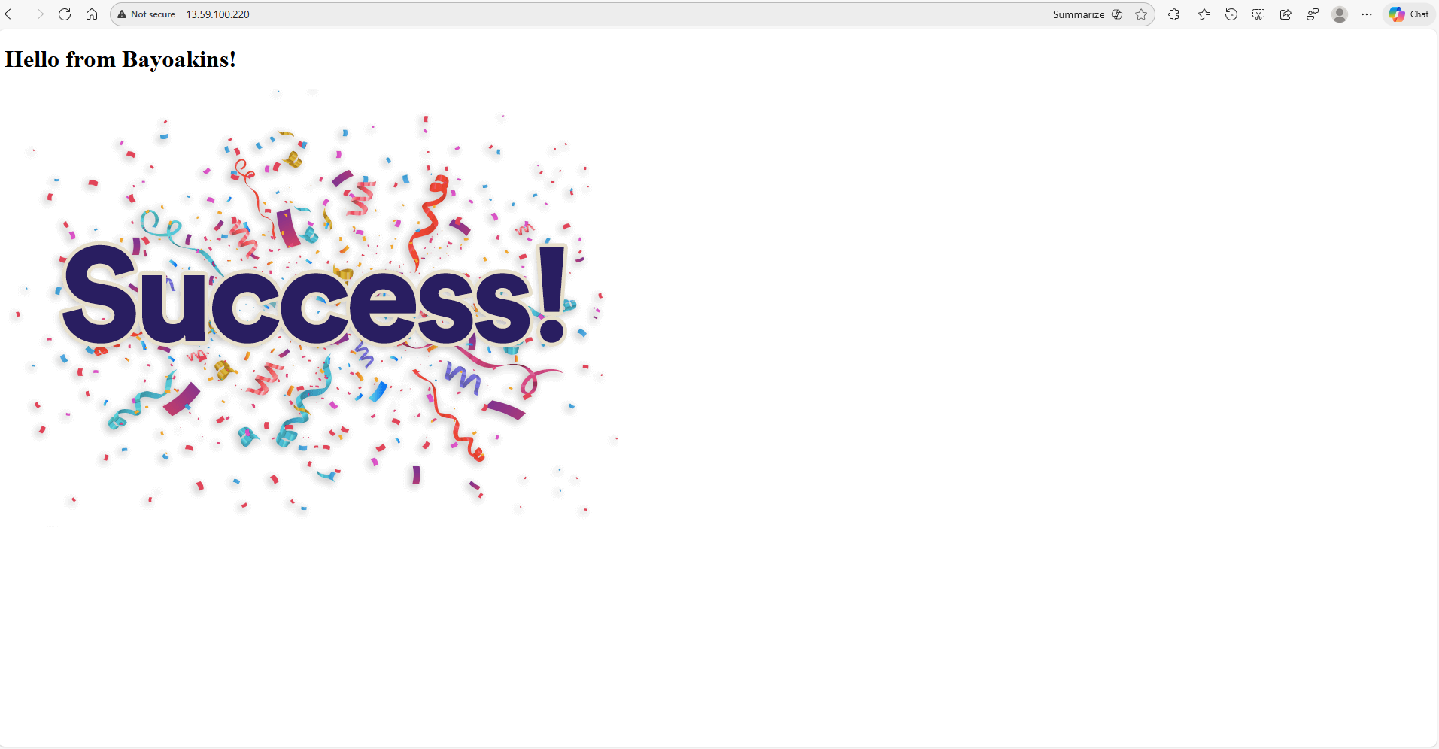

Cleanup
To avoid unnecessary billing, I deleted:
- The EC2 instance
- The security group
- The key pair
- The CloudFront distribution
- The S3 bucket
Cleanup is a crucial final step when working in a free-tier environment.
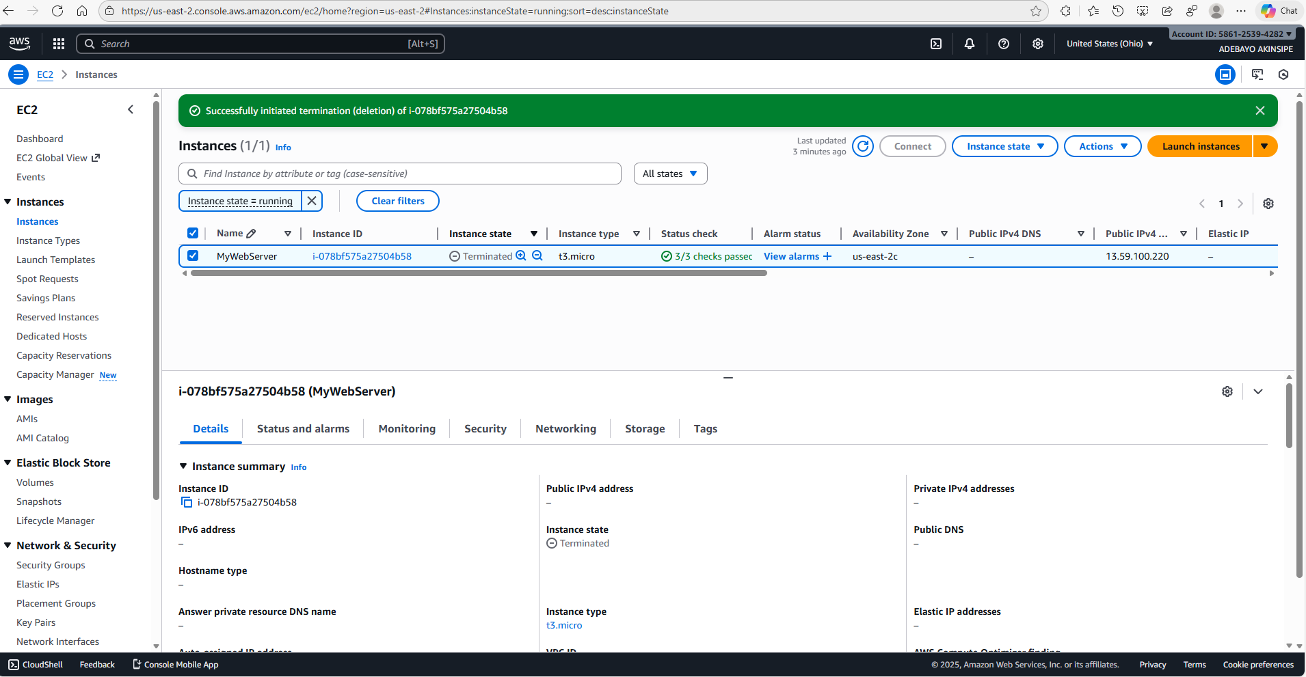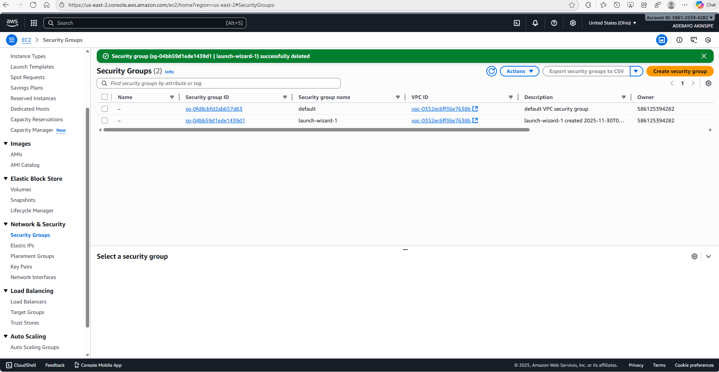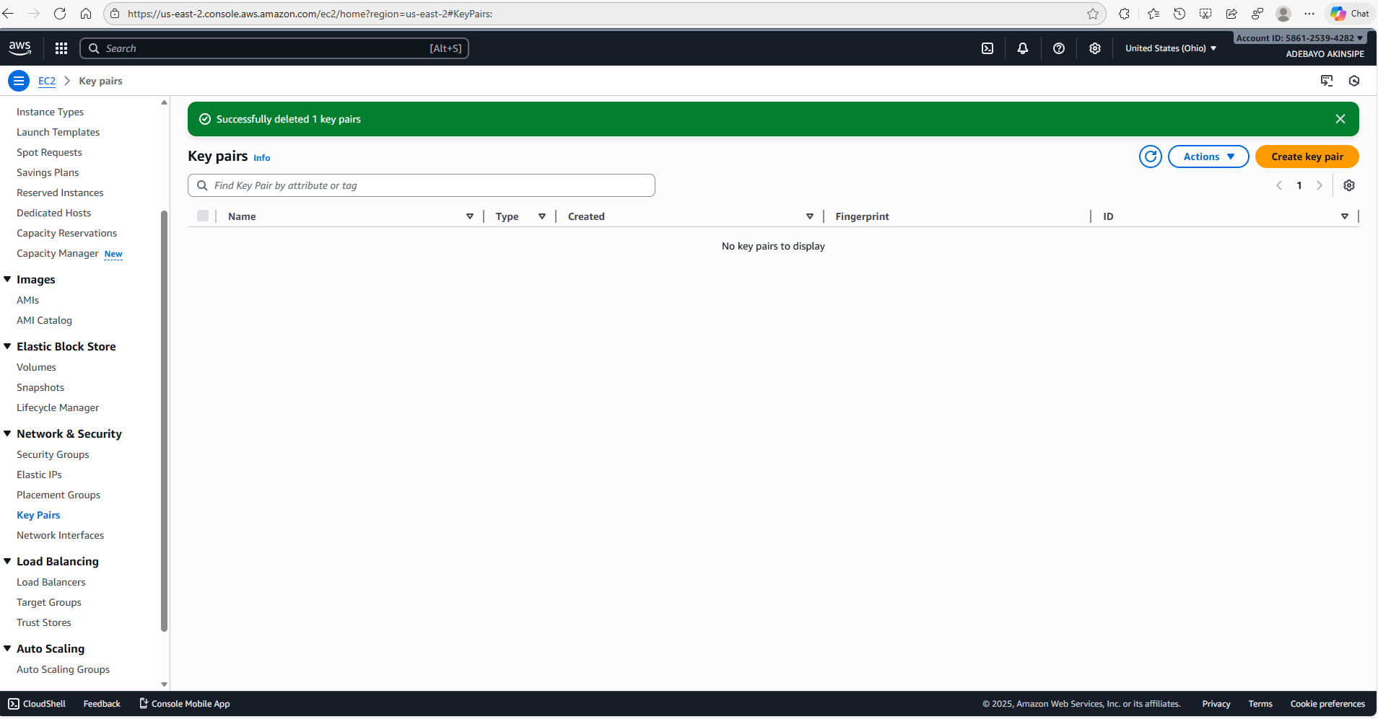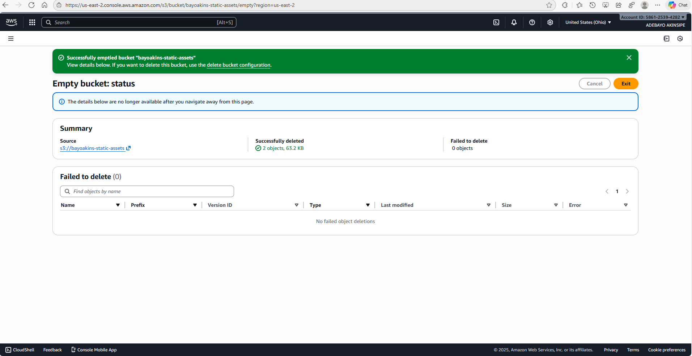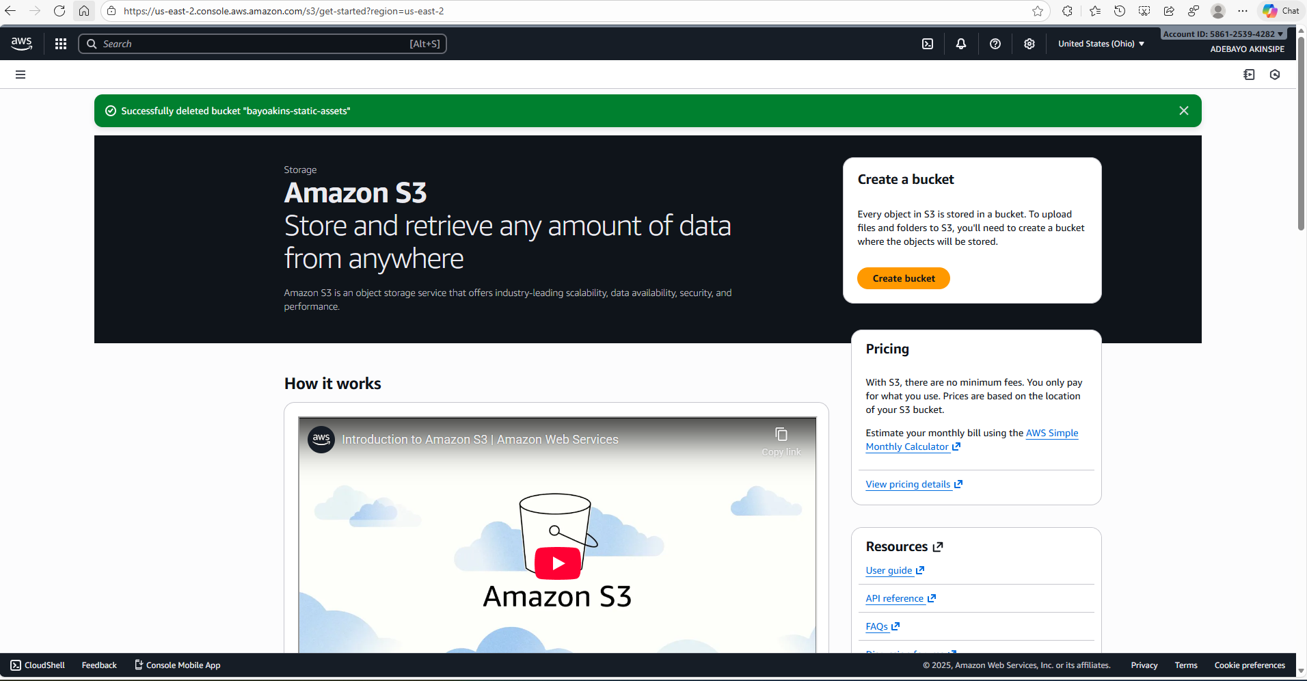

Troubleshooting Moment
My first test returned missing images — a classic 403 "Access Denied" error. The issue was that the HTML still referenced the S3 object URL instead of the CloudFront domain. After replacing the link, the assets loaded successfully.

Security + Performance Reflection
This project reinforced some important AWS design lessons:
- Decoupling Compute and Content Delivery improves scalability and cost efficiency
- CloudFront caching reduces latency and offloads traffic from the web server
- Private S3 buckets with controlled access paths reduce the attack surface
- Security groups and minimal access controls enforce the principle of least privilege

My Final Takeaways
This hands-on build helped me apply architectural reasoning rather than just service configuration. Working through each step deepened my understanding of how AWS services integrate — especially when designing secure, cost-optimized, and scalable web applications.
Next, I plan to extend this architecture with:
- HTTPS configuration
- Route 53 DNS mapping
- Lambda@Edge caching logic
Each improvement brings the build closer to production readiness — and one step further in my AWS Solutions Architect journey.

https://medium.com/@bayoakins_68523/building-a-hybrid-web-app-on-aws-ec2-cloudfront-s3-aa2e55f39f79

